**Introduction:**

A heap is a binary tree with two characteristics:

1) They must be complete binary tree.

2) The nodes must be ordered according to the Heap order property

**Types of Heaps:**

**1)** **Min Heap**: In this type of heap, the minimum-value element at

the root i.e. the value of parent node will always be less than or equal to the value of child node across the tree.

If Node A has a child node B, then:

key(A) <= key(B)

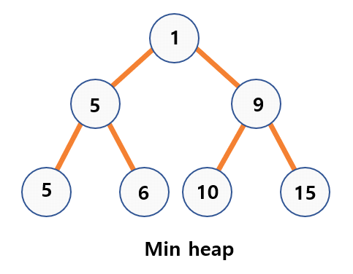

**2)** **Max Heap**: In this type of heap, the maximum-value element at the root i.e. the value of parent node will always be more than or equal to the value of child node across the tree.

If Node A has a child node B, then:

key(A) >= key(B)

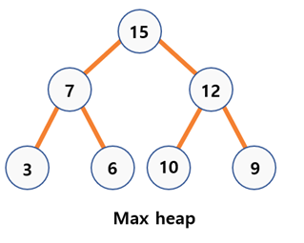

**Implementation of a heap:**

A heap can be represented in the form of array.

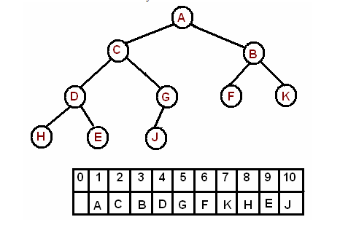

The root is the second item in the array. We skip the index zero cell of the array for the convenience of implementation. Consider i-th element of the array,

⦁ its left child is located at 2*i index

⦁ its right child is located at 2*i+1. index

⦁ its parent is located at i/2 index